**Design Thinking Project Workbook**

**Don't find customers for your product but find products for your customers**

**7. Team**

**Team Name:7**

**Team Logo (if any):**

**Team Members:**

1.2320040042-M.NIHARIKA(9121045822)

2.2320040044-B.SUDIKSHA NAIDU(9381124964)

3.2320040113-P.DEEKSHITHA SATYA(8978246778)

**2. Problem/Opportunity Domain**

**Domain of Interest:** VEGETABLE MART DATA ANALYSIS IN SMART CITY USING MACHINE LEARNING

**Description of the Domain:**.

The domain of vegetable mart data analysis is centered around understanding consumer behaviors, inventory management, supply chain optimization, and pricing strategies within urban settings. In a smart city context, data-driven decisions leverage advanced technologies like IoT sensors, big data analytics, and machine learning algorithms to enhance the efficiency and effectiveness of vegetable markets.

**Why did you choose this domain?:** We chose this project because As urban populations grow, ensuring access to fresh and affordable produce becomes a pressing issue. Data-driven strategies can enhance food security in cities. The integration of machine learning and data analytics in this domain allows for innovative solutions that can significantly improve efficiency and customer satisfaction. This domain combines insights from agriculture, economics, data science, and urban planning, making it an exciting field for collaborative and impactful work.

**3. Problem/Opportunity Statement**

**Problem Statement:** Vegetable marts often struggle with managing their stock of perishable goods effectively. Overstocks lead to increased waste, while understocks result in missed sales opportunities and customer dissatisfaction.

**Problem Description**: The convergence of these challenges creates a pressing need for an integrated, data-driven approach to manage the vegetable mart’s operations. The current reliance on traditional methods leads to inefficiencies, financial losses, and unsustainable practices, which ultimately hinder the ability to serve consumers effectively in an urbanized setting. Leveraging machine learning and data analytics could provide actionable insights and automated solutions to overcome these hurdles, leading to improved operational performance, enhanced customer satisfaction, and a more sustainable business model.

**Context (When does the problem occur):** The problems faced by vegetable marts typically occur during seasonal variations when demand fluctuates for specific vegetables, during peak shopping hours when unexpected surges in customer traffic lead to stockouts, and when supply chain disruptions, such as weather events or delays, hinder the timely availability of fresh produce. Additionally, issues can arise when ineffective pricing strategies fail to adapt to market conditions, and during promotional periods when demand may spike unexpectedly, leading to either excess inventory or shortages. Overall, these challenges can manifest at crucial operational times, affecting customer satisfaction and profitability.

**Alternatives (What does the customer do to fix the problem):** To address the challenges faced by vegetable marts, customers may implement a combination of strategies, such as utilizing data-driven inventory management systems that leverage real-time analytics for better demand forecasting, ensuring optimal stock levels, and minimizing waste. They might adopt dynamic pricing strategies informed by market trends and competitor analysis to adjust prices effectively. Furthermore, customers may engage in targeted marketing campaigns to understand and cater to consumer preferences, thereby enhancing customer loyalty and satisfaction. Additionally, improving supplier relationships and diversifying sourcing options can help mitigate supply chain disruptions, ensuring a steady flow of fresh produce. Through these proactive measures, customers can create a more efficient and responsive operational framework for the vegetable mart**.**

**Customers (Who has the problem most often**): The problem of managing inventory, demand forecasting, and pricing strategies most often affects small to medium-sized vegetable mart owners and operators who lack access to advanced analytics and resources compared to larger supermarkets or grocery chains. These retailers struggle with limited data insights, making it difficult to accurately predict consumer behavior and seasonal demand, leading to challenges such as excessive spoilage or stockouts. Additionally, they may face constraints in their supply chains, making them more susceptible to disruptions and fluctuations in product availability. Consequently, these vegetable mart owners frequently encounter the adverse effects of inefficient operations, impacting their profitability and customer satisfaction**.**

**Emotional Impact (How does the customer feel):** Customers of vegetable marts often feel frustrated and anxious due to the inconsistency in product availability and quality, especially when their favorite vegetables are out of stock or when fresh produce spoils quickly. They may experience disappointment if they encounter high prices that don’t reflect the quality or freshness of the items, leading to a lack of trust in the mart’s pricing strategy. Additionally, when faced with limited selection or poor customer service, they can feel undervalued as shoppers, prompting them to seek alternatives at competing retailers. Overall, these negative experiences can diminish their loyalty and satisfaction, leaving them disillusioned with their shopping experience.

**Quantifiable Impact (What is the measurable impact):**

**1. Increased Spoilage Rates:** Excess inventory due to inaccurate demand forecasting can lead to higher spoilage rates, often resulting in waste percentages of 20-30% for fresh produce, significantly impacting profitability**.**

**2. Lost Sales Opportunities:** Stockouts of popular items can translate to lost sales, with studies showing that retailers can lose up to 4% of revenue for each percentage point of stockout, affecting overall financial performance.

**3. Customer Turnover:** Poor inventory management and suboptimal shopping experiences can lead to decreased customer loyalty, potentially causing a turnover rate of 10-20% or higher, as customers seek more reliable alternatives**.**

**4. Reduced Profit Margins:** Ineffective pricing strategies can lead to unsustainable pricing, where profit margins may drop by 5-15%, impacting the long-term viability of the business and limiting reinvestment opportunities.

**5. Operational Costs:** Inefficiencies in supply chain management can result in additional operational costs, with estimates suggesting that these costs can increase by 15-25% when delays or disruptions occur, further squeezing profit margins and resource allocation.

**Alternative Shortcomings (What are the disadvantages of the alternatives):**

* **Limited Predictive Power:** Simple statistical methods may fail to capture complex patterns and relationships in large datasets**.**
* **Assumptions**: Many statistical techniques make assumptions (e.g., normality, linearity) that might not hold true in real-world data.
* **Manual Interpretation**: Data analysis can be subjective, relying on the analyst's expertise, which may lead to inconsistencies**.**
* **Feature Engineering Requirement**: Basic ML models often require significant manual feature selection and engineering, which can be time-consuming.
* **Overfitting**: Simple models may fit the training data too closely and perform poorly on new data.
* **Limited Complexity**: Basic models may not adequately capture non-linear relationships present in the data.

**Any Video or Images to showcase the problem: The evidence in the form of video or image).**

**Provide link if available**

**4. Addressing SDGs**

**Relevant Sustainable Development Goals (SDGs):**

* **SDG 2: Zero Hunger-** Data analysis can help optimize vegetable supply chains, reduce food waste, and ensure that fresh produce is available and accessible**.**.
* **SDG 8: Decent Work and Economic Growth-** Smart data analysis can enhance market efficiency and create more job opportunities within the agricultural and retail sectors.
* **SDG 11: Sustainable Cities and Communities**-  By using machine learning to analyze urban food systems, cities can promote sustainable urban agriculture and improve resource management.
* **SDG 12: Responsible Consumption and Production-** Machine learning can help reduce food waste and promote sustainable consumption patterns by tracking supply and demand more effectively.
* **SDG 13: Climate Action-** Analyzing environmental factors (like weather patterns) can help farmers adjust their practices to mitigate climate impacts on crop production.

**How does your problem/opportunity address these SDGs?:**

 SDG 2: Zero Hunger

* Problem Addressed: Food insecurity and malnutrition in urban areas due to inefficient food supply chains.
* Opportunity: Using machine learning to optimize supply chains and forecast demand can improve the availability and accessibility of fresh vegetables.
* Impact: More efficient distribution leads to reduced hunger and ensures that even vulnerable populations have access to nutritious food.

2. SDG 8: Decent Work and Economic Growth

* Problem Addressed: Lack of market information for farmers can hinder their ability to respond to demand, affecting income and job stability.
* Opportunity: By analyzing market trends and helping farmers understand consumer preferences, they can make better production and marketing decisions.
* Impact: Improved farmer livelihoods contribute to local economic growth and create more job opportunities within the supply chain.

3. SDG 11: Sustainable Cities and Communities

* Problem Addressed: Urban areas can struggle with food access due to inefficient logistics and market structures.
* Opportunity: Implementing smart solutions like urban agriculture data analysis can enhance food distribution and promote local food systems.
* Impact: Strengthening local food systems fosters resilient urban environments, reduces reliance on remote food sources, and supports community well-being.

4. SDG 12: Responsible Consumption and Production

* Problem Addressed: High levels of food waste in marketplaces due to supply-demand mismatches.
* Opportunity: By utilizing predictive analytics to better align supply with real-time consumer needs, food waste can be significantly reduced.
* Impact: More responsible production and consumption patterns contribute to overall sustainability and efficient resource use in urban environments.

5. SDG 13: Climate Action

* Problem Addressed: Agriculture’s vulnerability to climate change impacts and the need for sustainable farming practices.
* Opportunity: Machine learning can analyze environmental data, helping farmers adapt to climate variations and optimize resource use (e.g., water, fertilizers).
* Impact: Enhanced adaptive strategies lead to climate-resilient agricultural practices, supporting environmental sustainability while ensuring food security.

**5. Stakeholders**

Answer these below questions to understand the stakeholder related to your project

1. **Who are the key stakeholders involved in or affected by this project?**

1. Farmers and Producers: They are primarily affected as the project will provide insights into market demands, optimal planting schedules, and pricing strategies, directly impacting their income and production decisions.

2. Consumers: Local residents and consumers benefit from improved access to fresh, affordable vegetables. Their purchasing patterns and preferences can also inform market analyses.

3. Local Government and Policy Makers: They play a crucial role in implementing supportive regulations, providing funding, and ensuring the integration of strategies to enhance food systems and sustainability initiatives.

4. Retailers and Wholesalers: Businesses involved in the distribution and sale of vegetables will be impacted by better demand forecasting and logistics optimization, which can enhance their operational efficiency.

5.Technology and Data Analytics Firms: These stakeholders are essential for developing and implementing the machine learning tools and data analysis platforms necessary for the project, influencing technological adoption and innovation in the sector.

1. **What roles do the stakeholders play in the success of the innovation?**

* **Farmers and Producers:** They provide essential data regarding crop yields, planting schedules, and market prices, which is critical for accurate analysis and predictive modeling.
* **Consumers:** Their purchasing behavior and preferences inform demand forecasting models, ensuring that the data analysis aligns with actual market needs.
* **Local Government and Policy Makers:** They create supportive policies, funding opportunities, and regulatory frameworks that facilitate data sharing and technological integration in the agriculture sector**.**
* **Retailers and Wholesalers:** Their ability to leverage insights from market analysis directly influences product availability and pricing strategies, optimizing their operations and profitability.

1. **What are the main interests and concerns of each stakeholder?**

* Farmers are interested in maximizing their profits by understanding market demands and improving their production efficiency.
* Consumers are interested in having access to a wide variety of fresh, healthy, and affordable vegetables.
* They are interested in promoting food security and sustainability within urban areas through effective policies and initiatives.
* Retailers and wholesalers are interested in utilizing data insights to optimize their supply chain, reduce waste, and increase sales.

1. **How much influence does each stakeholder have on the outcome of the project?**

* Farmers have significant influence as they are the primary data providers whose practices will be impacted by the insights generated. Their adoption of recommendations based on data analysis will directly affect project success and sustainability.
* Consumers influence the project through their purchasing behaviors and preferences. Their acceptance and advocacy for local products can drive demand, consequently impacting the success of the project.
* Local government officials have significant power in establishing policies and frameworks that support the project’s goals. Their decisions regarding funding, infrastructure development, and regulatory support are critical..
* Retailers and wholesalers can decisively impact the project by utilizing the insights from data analysis to optimize their operations. Their commitment to local sourcing and supporting farmers can enhance market dynamics.

1. **What is the level of engagement or support expected from each stakeholder?**

* Farmers should provide information on crop yields, planting schedules, and market conditions, as well as implement recommendations based on insights.
* Consumers are expected to engage primarily by providing feedback regarding product quality, preferences, and behaviors through surveys or focus groups.
* Strong support and active involvement are needed from local government officials in promoting policies that facilitate data sharing and technology adoption.
* Retailers and wholesalers should actively participate in market analysis discussions and collaborate with farmers and consumers to optimize supply chains and meet demand.

1. **Are there any conflicts of interest between stakeholders? If so, how can they be addressed?**

* Farmers may prioritize higher prices for their produce to increase their income, while retailers and wholesalers aim to keep costs low to maximize sales and profit margins. This can lead to tension over pricing and profit sharing.
* Consumers may prioritize low prices and convenience, which can conflict with farmers’ needs for fair compensation for their products. If consumers consistently opt for cheaper, mass-produced vegetables, local farmers may struggle to survive economically.

1. **How will you communicate and collaborate with stakeholders throughout the project?**

* Organize regular meetings (e.g., monthly or quarterly) with all stakeholders to discuss project progress, share insights, and address concerns. These meetings can be held in-person or virtually, depending on participants' availability.
* Create advisory committees that include representatives from each stakeholder group (farmers, consumers, retailers, government, and technology firms). These committees can provide feedback, share insights, and help guide project decisions based on diverse perspectives.
* Regularly send email updates to stakeholders outlining project milestones, upcoming events, and important insights or data findings. This ensures everyone stays informed and engaged.
* Use surveys and polls to gather feedback from stakeholders on specific topics or project aspects, such as data usefulness, user experience, and areas for improvement. This helps tailor efforts to meet stakeholder needs better.
* Provide regular reports summarizing data analysis findings, project outcomes, and stakeholder contributions. This transparency builds trust and encourages continued collaboration.

1. **What potential risks do stakeholders bring to the project, and how can these be mitigated?**

* Farmers or other stakeholders may resist adopting new technologies or data-driven practices, fearing disruption to their established methods or uncertainty about benefits.
* Stakeholders may be concerned about the privacy and security of the data being collected, fearing misuse or unauthorized access, which could lead to reluctance in sharing information.
* Different stakeholders may have competing interests (e.g., farmers wanting higher prices vs. consumers wanting lower prices), which can lead to conflicts that disrupt project progress.
* If stakeholders do not actively engage or participate in the project, it could lead to insufficient data collection, lack of feedback, or disengagement from key groups.
* Limited resources, whether financial, technological, or human, could hinder the project’s progress and ultimately affect outcomes

**6. Power Interest Matrix of Stakeholders**

**Power Interest Matrix: Provide a diagrammatic representation of Power Interest Matrix**

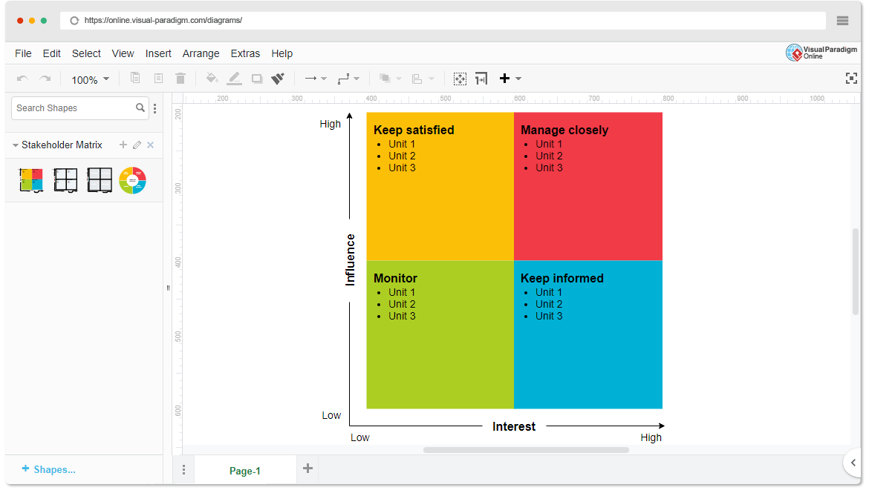

* High Power, High Interest: [Market Regulators, Large suppliers, Investors]
* High Power, Low Interest: [Local government authorities, Infrastructure Providers, Smart city platform providers]
* Low Power, High Interest: [Local farmers, Vendors in mart, Market customers]
* Low Power, Low Interest: [General public, NGOs focused on niche areas, Minor technology providers]